Task 3

Project: Event Management System using PostgreSQL.

Part1: Database Creation

Create a database named "EventsManagement."

Create tables for Events, Attendees, and Registrations.

Events- Event_Id, Event_Name, Event_Date, Event_Location, Event_Description

Attendees- Attendee_Id, Attendee_Name, Attendee_Phone, Attendee_Email, Attendee_City

Registrations-Registration_id, Event_Id, Attendee_Id,Registration_Date,Registration_Amount.

The FOREIGN KEY constraint in the Registrations table references the Event_Id column in the Events table and the Attendee_Id column in the Attendees table.

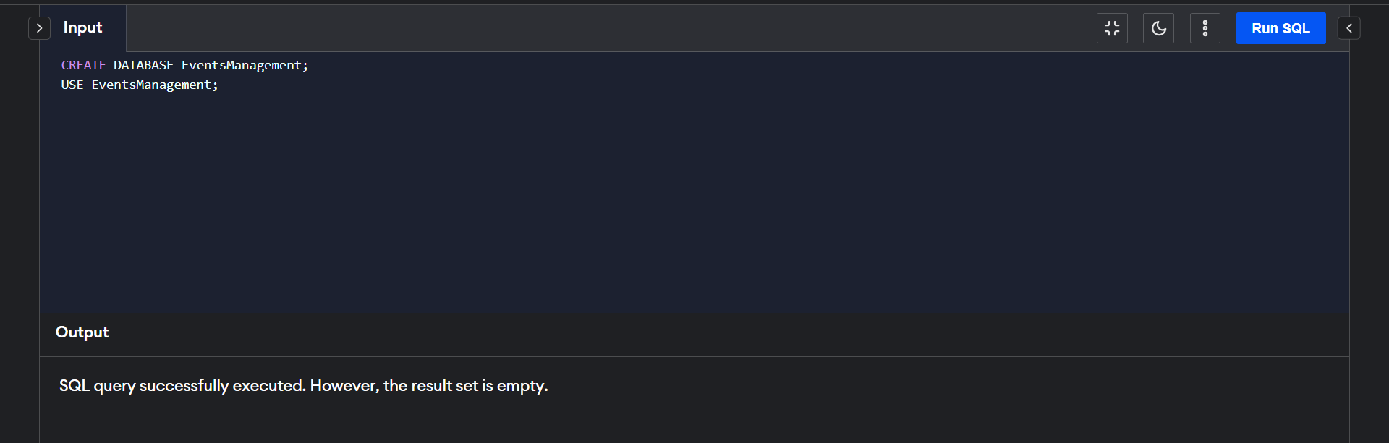

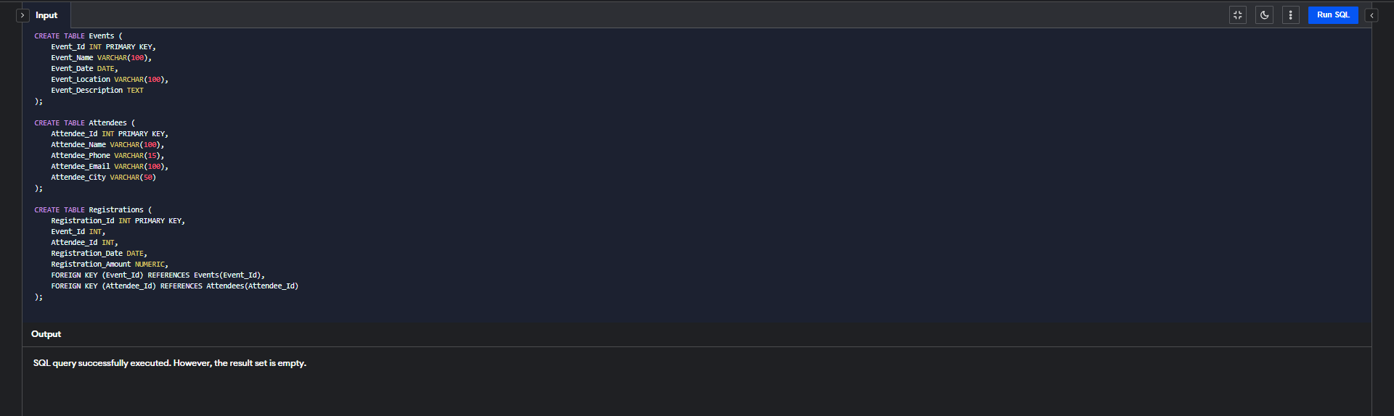

Part 2: Data Creation

Insert some sample data for Events, Attendees, and Registrations tables with respective fields.

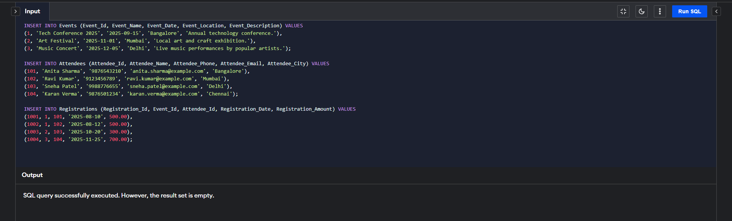

Part 3: Manage Event Details

a) Inserting a new event.

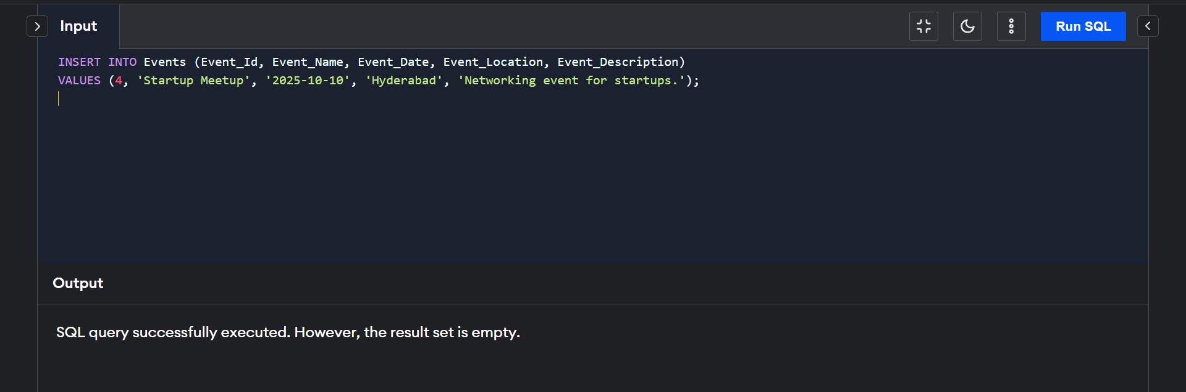

b) Updating an event's information.

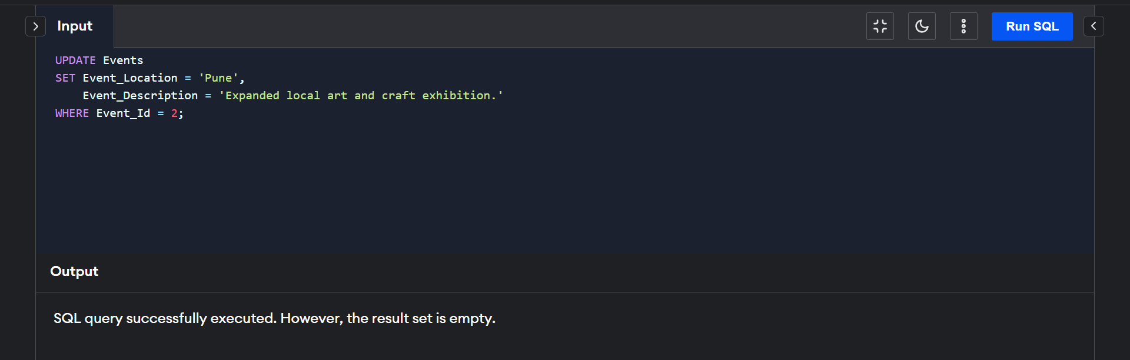

c) Deleting an event.

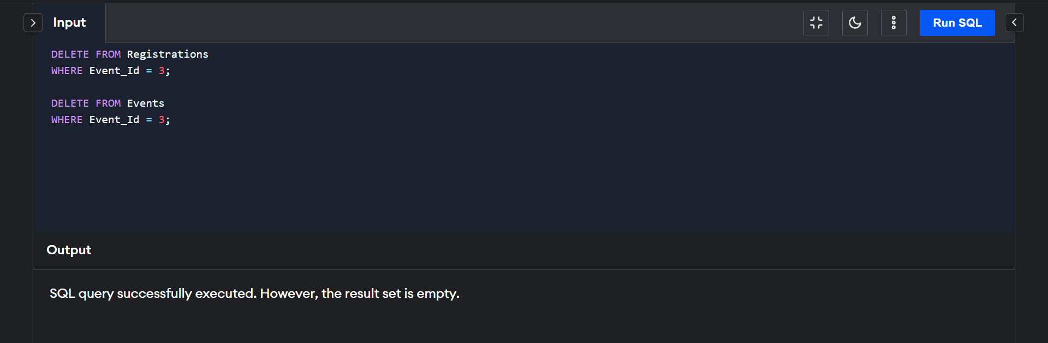

Part 4: Manage Track Attendees & Handle Events

a)Inserting a new attendee.  
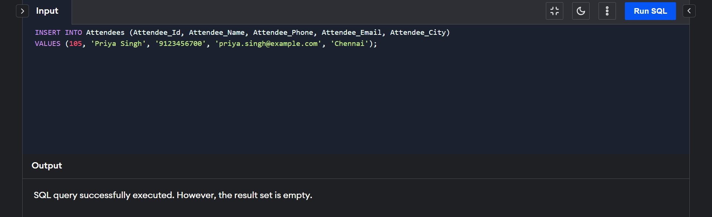

b)Registering an attendee for an event.

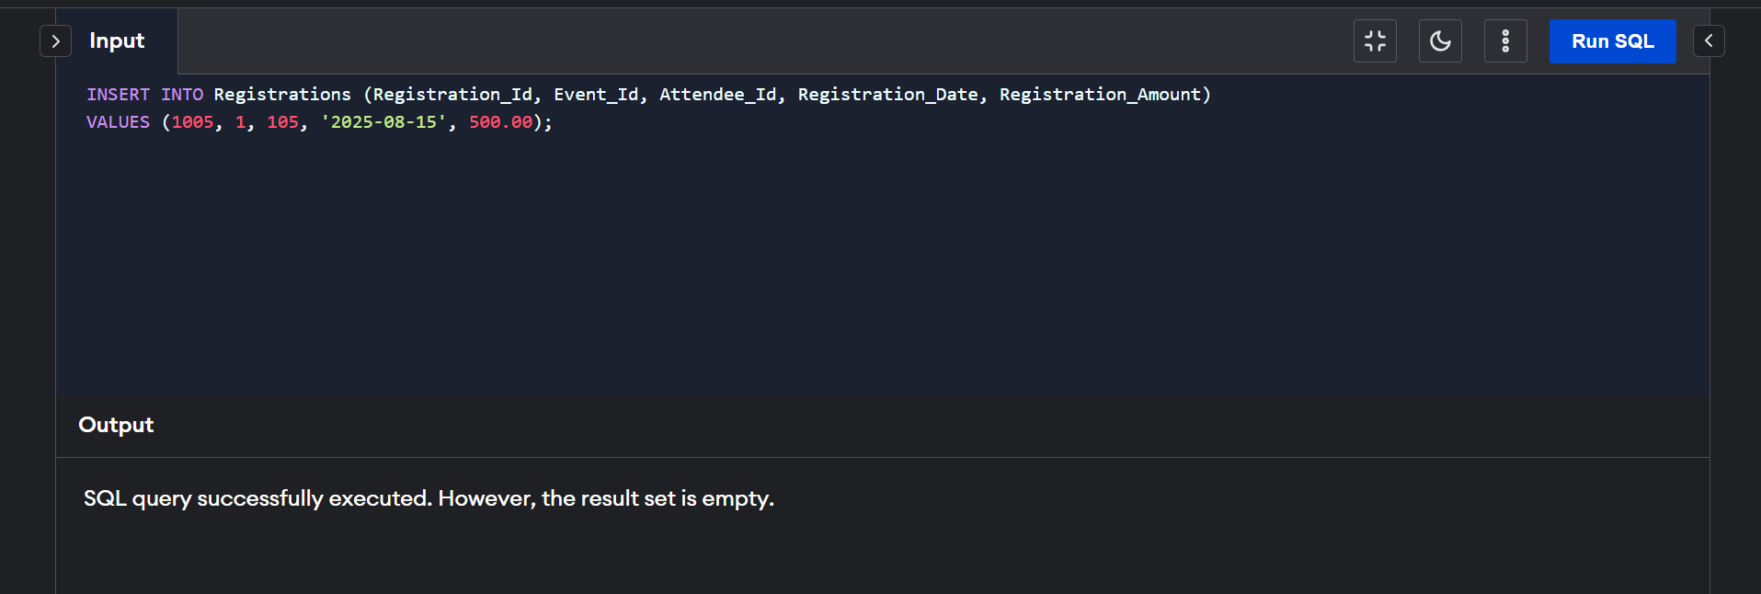

Part 5: Develop queries to retrieve event information, generate attendee lists, and calculate event attendance statistics.

